Life ‘before’ and ‘after’ Snehagram: An institutional case study
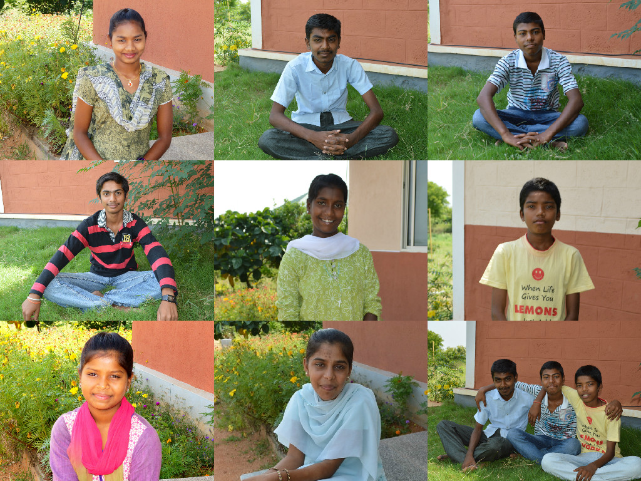
Different faces. Same story. Stigma, discrimination and HIV

Life before Snehagram:

These are stories of few children at Snehagram but who collectively represent the different scenarios and background of Orphans and Vulnerable Children with HIV in India and their major challenges. These stories help to throw light on the impact of Snehagram and its programmes on the quality of life of these children and the need for such residential care, treatment and support institutions and facility to address the issues of Children Affected By HIV/AIDS (CABA) and Children Living with HIV (CLHIV).

For 16 year old Ashwini from Bidar district in Karnataka, stigma and discrimination entered her life soon after her parent’s death from HIV/AIDS. Ashwini and her younger brother Akash went to live with their mother’s family after they became orphans but their suffering did not end with losing their parents. In more ways than one, it just seemed to begin. Ashwini’s grandmother began to isolate her from the rest of the family which caused her immense pain and humiliation. Separate plate and glass to use and different set of bed clothes made Ashwini to feel dejected and uncared for. Fear of transmission of HIV from Ashwini to others in the family was the cause of such behavior.

Meena, 15 from Maddur town in Mandya district in Karnataka has a similar tale of receiving ill treatment from family members after parent’s death. Burdened with household chores, not being given food to eat, spoken to with no dignity and consideration are aspects of the traumatic life that orphans and children with HIV live. She remembers with pain,

‘My maternal uncle’s wife used to cook for only them and I used to watch them eat. Even in my mother’s last days before HIV finally killed her, my uncle and his wife did not look after my mother. I saw her die from negligence as much as from HIV.’

For Siddhuramu, 16 from Maddur it became tough to cope after parent’s death when he found there was no one to support him and his sister. They got separated – he lived with his mother’s family and his sister with their father’s family. For Sachin, 14 from Bidar remembering to take Ante Retroviral Therapy (ART) on time at home was a great challenge. Kalesh, 15, from Bidar remembers how doctors in the hospital suspected him and his younger brother to be infected with HIV when his mother died from the same disease there. Till then their HIV status was unknown. On testing Kalesh was found infected with the virus and treatment was started for him.

The children may be different and from different geographies but it is the same story of stigma and discrimination, absence of a support group and lack of care, a hostile environment within and beyond home, safety issues, of unknown HIV status, of delay in treatment, of lack of access to ART and issues of adherence, of malnutrition, of lack of opportunities in education, vocation and giving up.

Snehagram- Believing in life after HIV/AIDS

Snehagram is a 17 acre residential facility for orphan and vulnerable children with HIV situated in Nachikuppam in Krishnagiri district of Tamil Nadu with the mission to ensure quality of life, leading them to a healthy and productive adulthood through education, good health, psycho-social support, vocational training and life skill education.

Through its specialized school, vocational skills trainings, a comprehensive health management program with special emphasis on HIV/AIDS, sports activities and yoga, events like ‘Champion in Me’, Summer Camps, Child Parliament and involvement of children in the administration of Snehagram, the institution has been able to develop leadership skills in the children and empower them in terms of good health, level of awareness of HIV and skills to negotiate with family and community to overcome stigma and discrimination, achieving life aspirations and goals and believing in life after HIVAIDS.

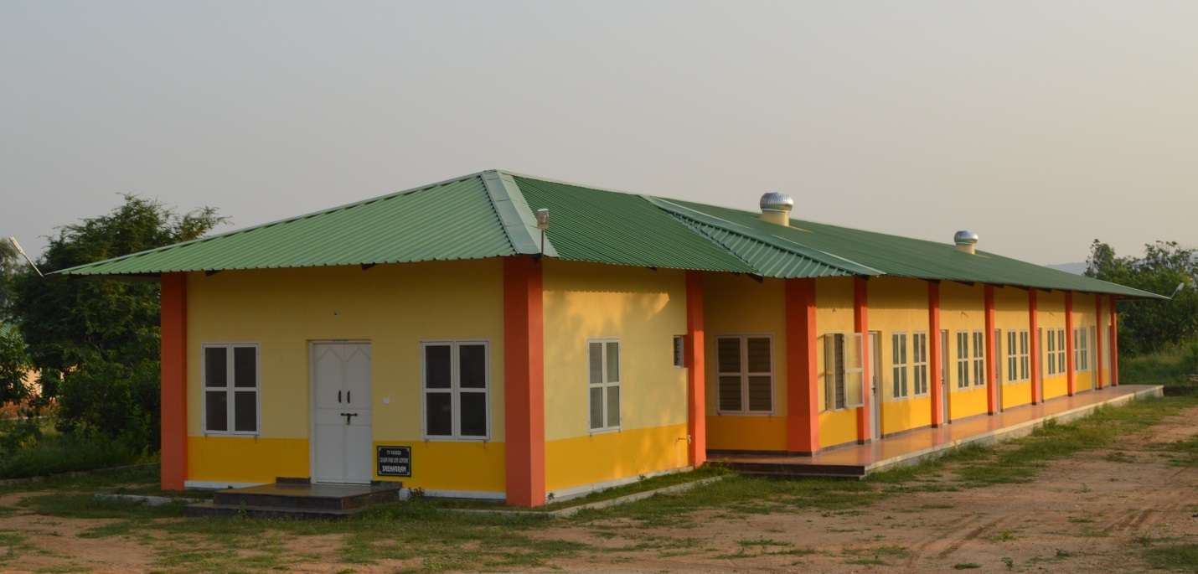
Learn for Life Centre
Learn for Life Centre, the residential school at Snehagram offers children specialized education allowing each child to choose a subject suitable to individual aptitude and aspirations while completing their secondary and higher secondary level of education under the National Open School (NOS).

Vocational training: Children receive vocational training in Snehagram to develop in them skills required to get a job and earn a stable livelihood. These trainings are on computer programming, language and communication, customer care services, BPO/ITES industry, crafts, tailoring and embroidery and agriculture and farming with exposure to skills in cattle and poultry farming. Children are involved in farming in the land inside the campus and take lead in maintaining this kitchen garden in turns.
“I want to have my own tailoring school to teach poor children who are not educated to help them to stand on their own feet”-
Life goal of Ashwini, class 9 student, recipient of vocational training on tailoring for children.

Sachin, 19, from Mysore learnt photography and the basics of videography in such trainings and can now handle the DSLR Nikon professional camera with as much ease as a professional photographer would. He photo documents all the events and programs at Snehagram and wants to grow to become a journalist.

These vocational trainings have helped these children to think beyond academics and mentored their overall development and given them additional skills to help them prepare for jobs and get financially independent.

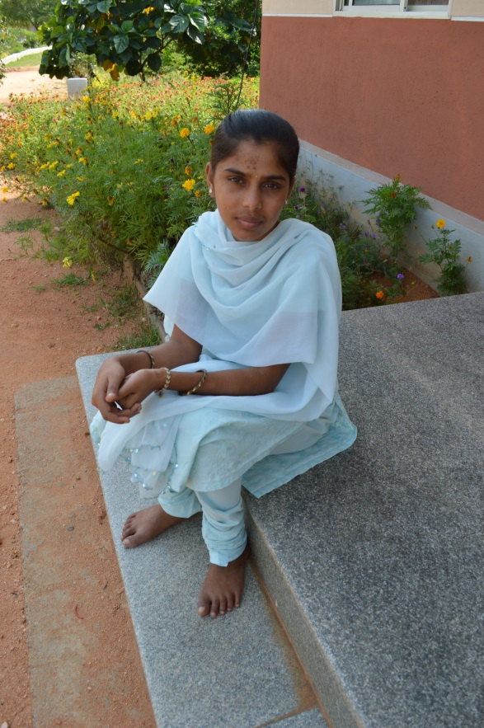
Comprehensive Health Management: The clinic at Snehagram, with an on-site nurse and a group of doctors available for consultations, focuses on prevention of opportunistic infections through regular monitoring and evaluating immunity status and viral load of children who are integrated to the Anti-Retroviral Therapy (ART) provided by the National AIDS Control. Referrals are made to Snehacare and St. John’s Hospital in Bangalore. Besides management of HIV/AIDS, Snehagram looks into the nutrition, good health and overall well- being where children spend early morning time in yoga and running and acres of land have been planted with fruit trees like mango, papaya, sapota etc. to provide for good nutrition.
Ashwini, a tailor instructor in the making

Sachin had difficulty in taking ART regularly at home after both his parents died from HIV ten years ago and his health suffered a major set -back where doctors declared him ‘dying’ at the hospital in Mysore. He was taken to Snehadaan where he was treated and received care and support till he finally moved to Snehagram when he turned fourteen. Sachin enjoys good health now and says, ‘I can’t believe what a U-turn my life has been after the care and support from Snehagram.’

Child Parliament: The Child Parliament is another unique programme at Snehagram facilitated by INSA-India and aims to provide sustainable and meaningful opportunities for children to participate in local, national and democratic processes for the larger purpose of attaining child development, survival and protection. Under the Child Parliament program, children are being elected as ministers to different ministries following the democratic system. There is a minister for education, environment, health, law and sports- each looking after areas assigned to them. The Environment Minister looks after the cleanliness, the plantations around the campus and watering them while the Law minister looks that there is no use of profanity and no violence among children. There is a Prime Minister, cabinet of ministers, shadow ministers and helpers who collectively identify issues from the point of view of a CABA/CLHIV, bring it to the notice of the administration and management of Snehagram, recommend solutions, facilitate discussions, bring out resolutions and enact it. The children through the Child Parliament are acquiring leadership skills and getting involved in the governance of the institution and getting empowered.
‘The good thing about having Child Parliament in schools is we can take leadership and govern ourselves without depending on instructions from adults for everything with just some support.”
- Kalesh, 15, Law Minister, Child Parliament

Ashwini, the Health Minister, shares how high levels of ART adherence among the children has been made possible by stringent monitoring on a daily basis by her along with the help from shadow ministers and helpers. She says, ‘ My role is to identify which of us is not taking ART, water, fruits and vegetables regularly and report it to the management of Snehagram to control children who do not take ART regularly.’
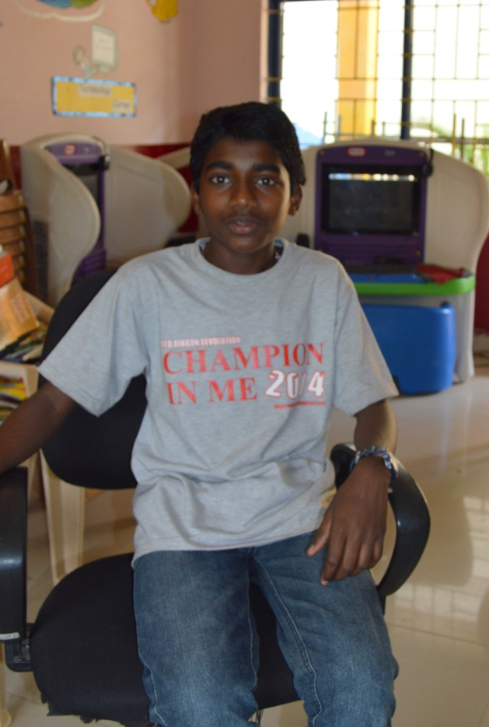
Champion in Me and Sports: The Champion in Me is an annual arts & sports event for the children living with HIV which was launched with an aim to unearth the hidden talents of children and provide a platform to exhibit their competencies in arts and sports. Every year it is held at Snehadaan Campus at Bangalore where several hundred children participate in different cultural and sports competitions, win prizes and learn the importance of cooperation and lending ears to the ideas of others. The Champion in Me and the training at Snehagram were the spiraling influence on Babu Seenappa and Manik Prabhu’s success in different marathons and their participation at the International Children’s Games/Olympics at Netherlands between June 24-29,2015. For the first time in the history of the global sports event two children who have HIV are participating and defying the myth that being HIV positive is the end of the road.
Marathon Champion Babu Seenappa

Life after Snehagram

In the words of the children, life after Snehagram is markedly different from life before they came here. For some, ART adherence and health have improved remarkably almost like a steep U-turn, yet for few others it has made life less stressful away from the stigma and discrimination at home and the positive, caring environment at Snehagram. Few talk about acquiring new skills of tailoring, computers, operating a sophisticated camera, speaking good English, playing a new sport or getting to eat fruits daily while others talk about how their own knowledge about HIV and its mode of transmission has helped them go back to their family which used to isolate them and educate them. These children are happy that they have acquired the power of negotiation and altering their environment to one that is empathetic to

their HIV status. Few select children like Babu and Manik will compete with other children in the world for international recognition and performance in sports while children like Meena who have been a Prime Minister at the Child Parliament may go ahead to take bigger roles as an adult when they grow up. The possibilities are endless but the starting point for these children was giving them an environment of acceptance, love and nurturing, of recognition and encouragement, of good medical care, treatment and support to manage their HIV/AIDS and general health and a belief in life after HIV/AIDS.
“Counseling made me a bold girl and taught me how to handle my own feelings of despair at being treated badly by my uncle’s wife at home. It’s almost like I got my childhood back.’
-Meena, 15, Prime Minister,
Child Parliament

** Note: Snehagram is a learning site of Karnataka Health Promotion Trust (KHPT) for its HIV/AIDS Orphans and Vulnerable Children Social Protection Project which is funded by USAID and implemented in 16 districts across the three states of Maharashtra, Karnataka and Tamil Nadu to increase access to priority health, educational, social protection and welfare services by children affected by HIV/AIDS (CABA). The learning site at Snehagram serves to demonstrate to other programs and other states how an institution based intervention is focused not just on care and treatment of CABA but also links them to opportunities related to education, over all development and vocation.

